**Road Accident Dashboard - Tableau Project Report**

* **Project Overview:**

The Road Accident Dashboard is an interactive Tableau visualization designed to analyze and present key insights about road accidents in UK. It allows users to monitor accident trends, casualty figures, and contributing factors using dynamic charts, filters, and KPIs.

* **Dataset Used:** <https://www.kaggle.com/datasets/charliescott556/uk-vehicle-accident-database-2019-2022>
* **Objectives**
* To visualize and compare yearly road accident statistics.
* To analyze casualties by vehicle type, road surface, weather conditions, and location.
* To provide interactive filtering (by year, accident severity).
* To help identify key factors contributing to serious accidents.
* **Key Features**
* **Filters & Parameters**
* Current Year and Previous Year selectors (2019,2020,2021,2022)
* Accident severity selector (Serious, Fatal, Slight).
* **KPIs**
* **Total Accidents**: 1,44,419 (↓ 11.70% YoY)
* **Total Casualties**: 1,95,737 (↓ 11.89% YoY)
* **Fatal Casualties**: 2,855 (↓ 26.40% YoY)
* **Serious Casualties**: 27,045 (↓ 16.30% YoY)
* **Slight Casualties**: 1,65,837 (↓ 10.82% YoY)
* **Charts**
* **Sparklines** for monthly trends (J-F-M…D) for different casualty types.
* **Bar chart** for serious casualties by road type (e.g. single carriageway, dual carriageway).
* **Pie charts / donut charts** for serious casualties by:
  + Weather condition (Fine, Rain, Snow/Fog, Others)
  + Road surface (Dry, Wet, Frost/Snow)
* **Map view** plotting accident locations using geospatial data.
* **Visualization Components**
* Bar chart highlights major contributors (e.g. 21,235 serious casualties on single carriageway roads).
* Pie charts make it easy to see proportions (e.g. 83.73% of serious casualties occurred in fine weather).
* Map shows the distribution of serious accidents across the UK.
* **Interactivity**
* Users can filter accident data based on year and severity level.
* All visuals update dynamically as filters are applied.
* **Insights from the Dashboard**
* There’s a **year-on-year decrease** in accidents and casualties.
* **Single carriageway roads** contribute most to serious casualties.
* Most serious accidents happen in **fine weather** and on **dry roads**, suggesting human factors are more critical than just environmental conditions.
* Geographical clusters of accidents are visible in high-density regions (e.g. London, Midlands).
* **Interactive Dashboard:**

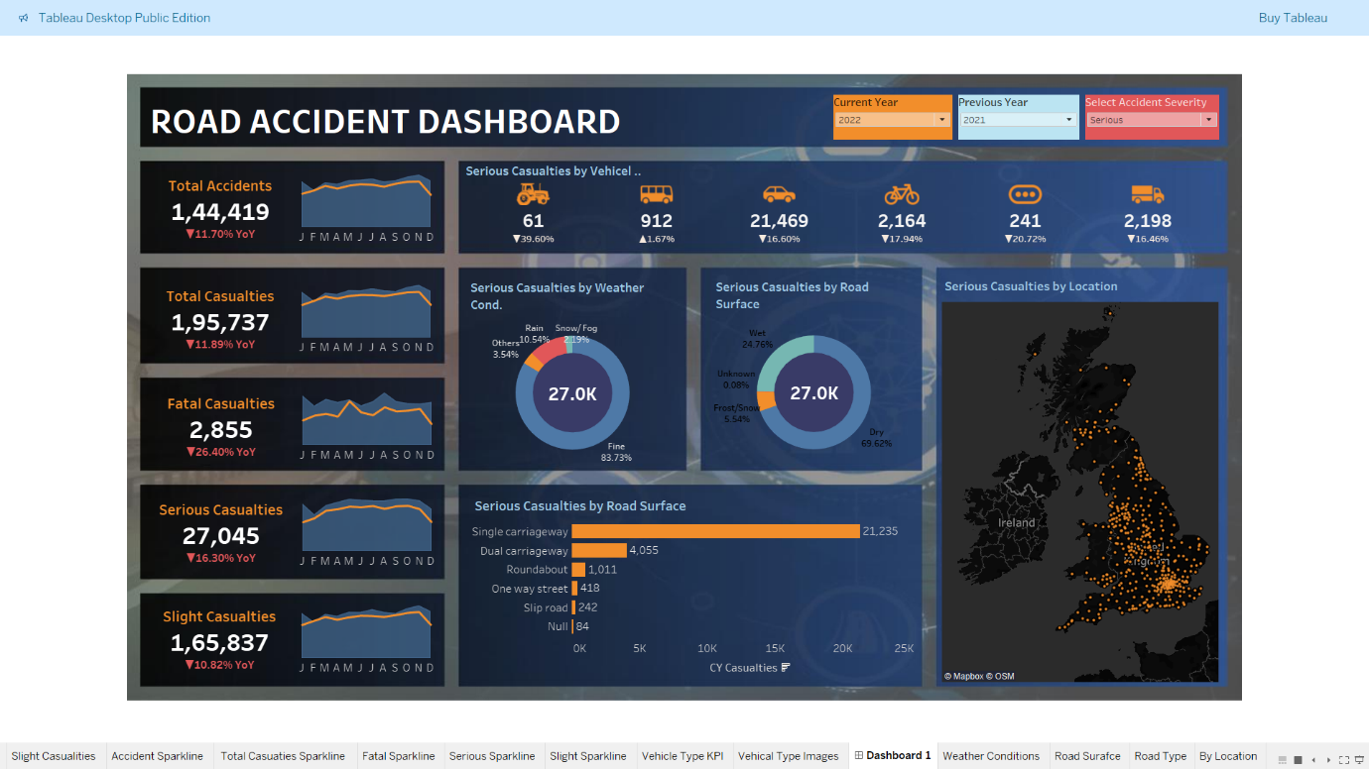

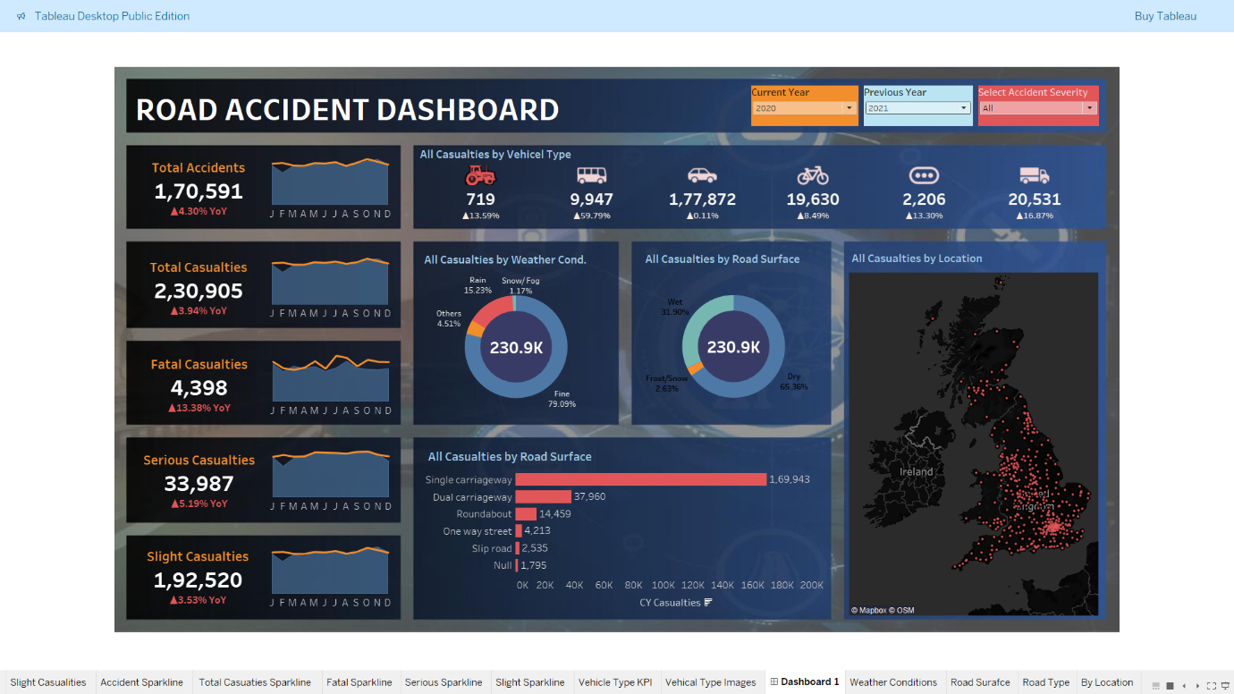

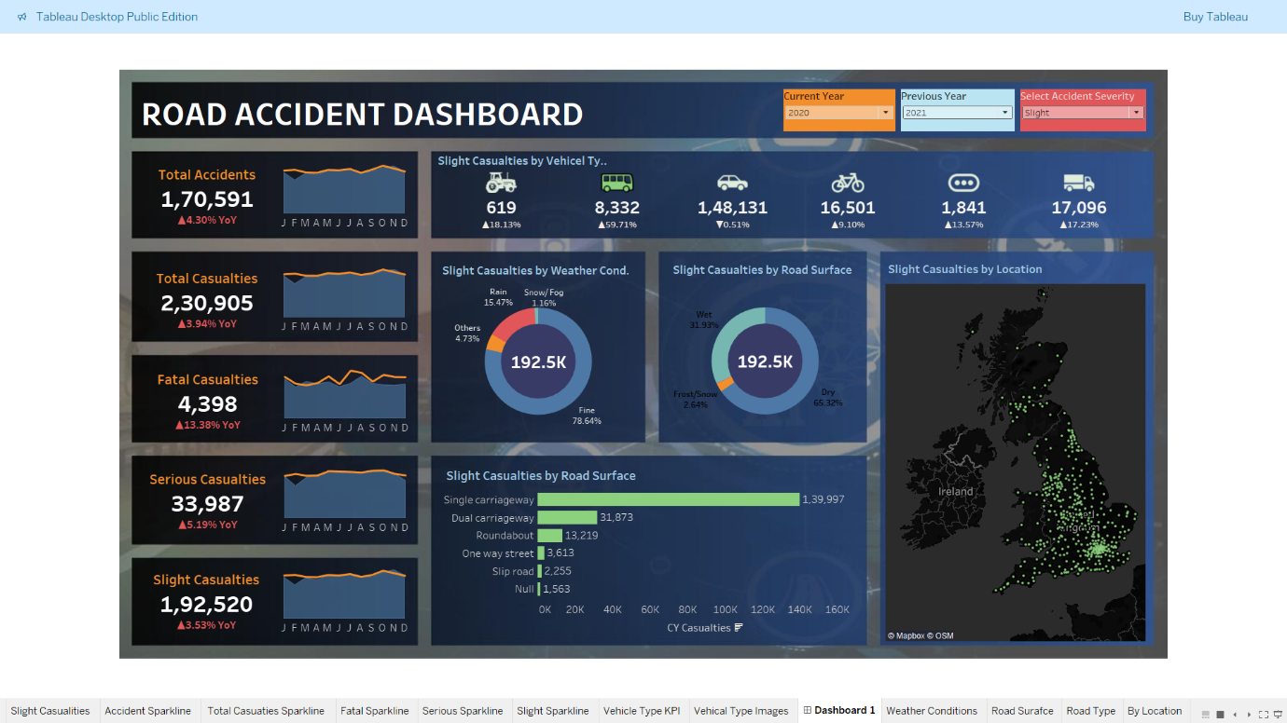

* **Charts:**



